28.68: The horizontal wire yields zero magnetic field since 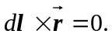 The vertical current provides the magnetic field of HALF of an infinite wire. (The contributions from all infinitesimal pieces of the wire point in the same direction, so there is no vector addition or components to worry about.)
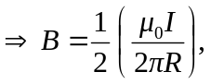
and is out of the page.

